Steps to Design a Calculator App in Figma

================================

1. Create a New Design File
- Open Figma
- Click New Design File
- Rename it:
  - Calculator App UI

2. Create the Main Frame
Frames act like application windows.

Steps
- Press F → choose Desktop Frame
- Example size:
  - 400 × 700 px

Recommended
Use:
- Rounded corners
- Light or dark background
- Shadow effect
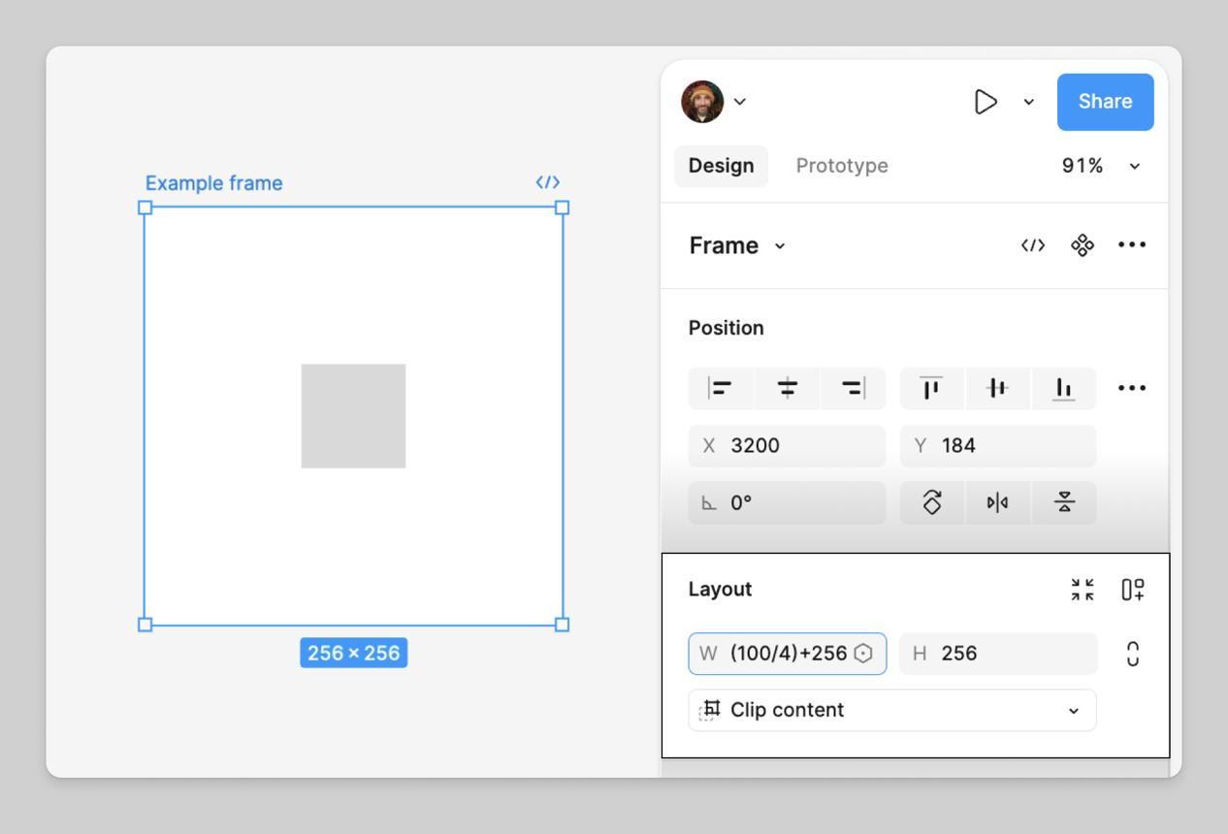
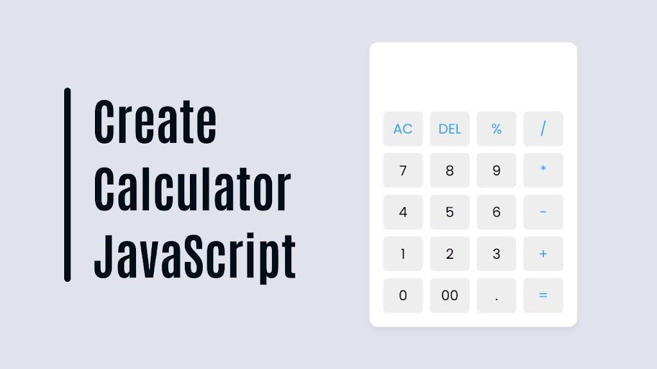
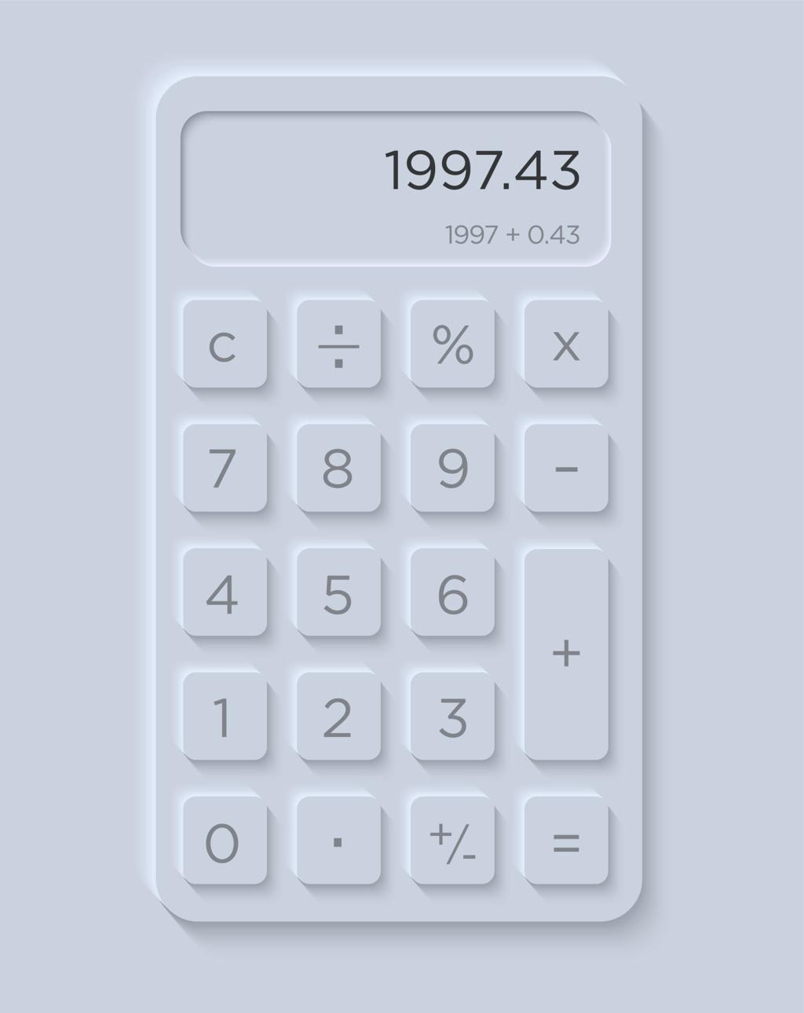

3. Design the Display Screen
This is where numbers appear.

Add
- Large rectangle at top
- Right-aligned text

Example
245 + 17
262

Suggested Styles
- Font: Inter / Roboto
- Large font size
- Dark display background

4. Create Button Grid
Create buttons for:
- Numbers (0–9)
- Operators (+ − × ÷)
- Equals (=)
- Clear (C)

Best Layout
Use:
- 4 columns
- Equal spacing
Example:
C | % | ÷ | ×
7 | 8 | 9 | −
4 | 5 | 6 | +
1 | 2 | 3 | =
0 | . | +/- | ✓
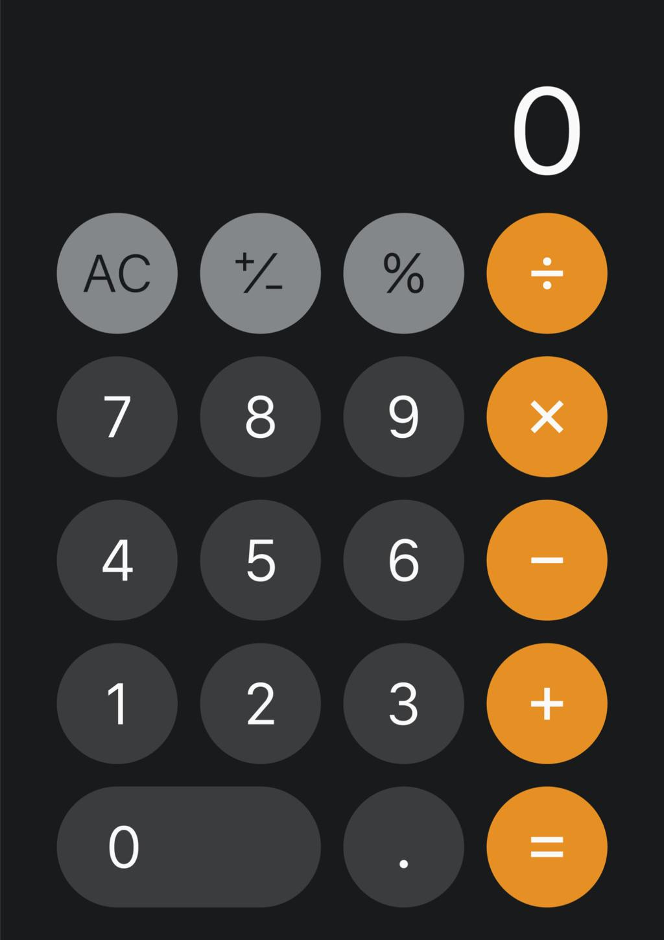
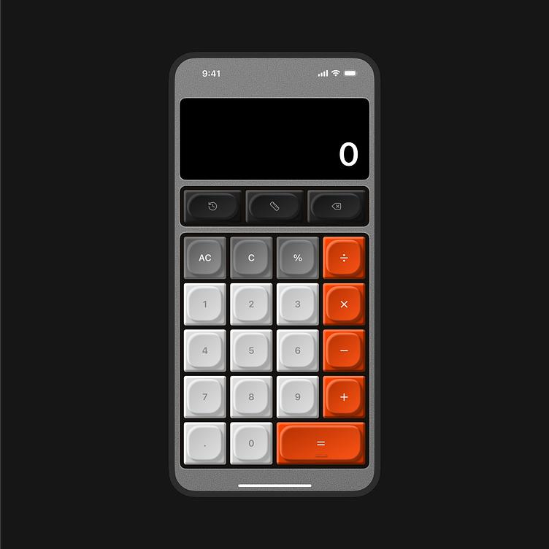


5. Use Auto Layout
Auto Layout helps buttons resize automatically.

Steps
- Select buttons
- Press:
  - Shift + A

Benefits
- Equal spacing
- Responsive resizing
- Easier editing

6. Create Components
Convert buttons into reusable components.

Steps
- Select one button
- Right click →
  - Create Component
Now duplicate it for:
- Numbers
- Operators
- Function buttons

Advantages
- Faster editing
- Consistent design
- Easier prototyping

7. Add Variants
Variants create multiple button states.
Example:
- Normal
- Hover
- Pressed

Steps
- Select component
- Click:
  - Add Variant
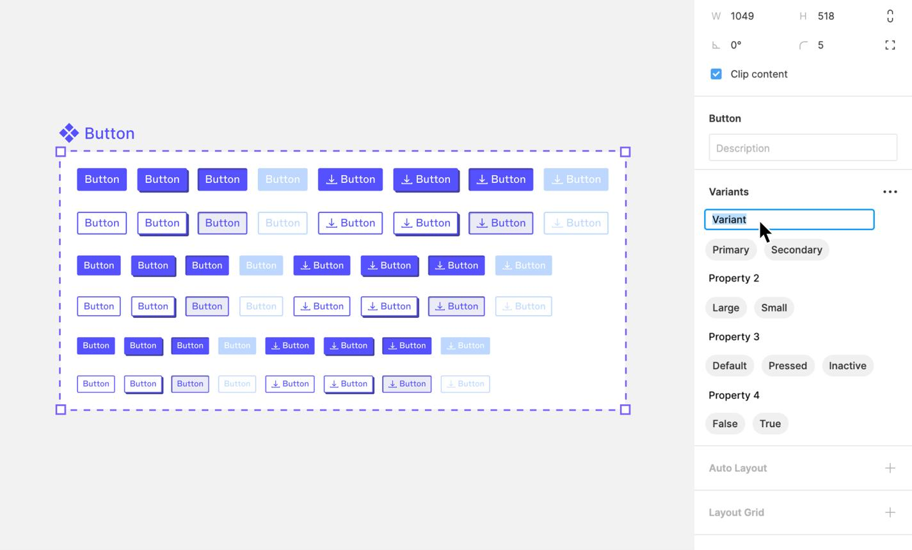
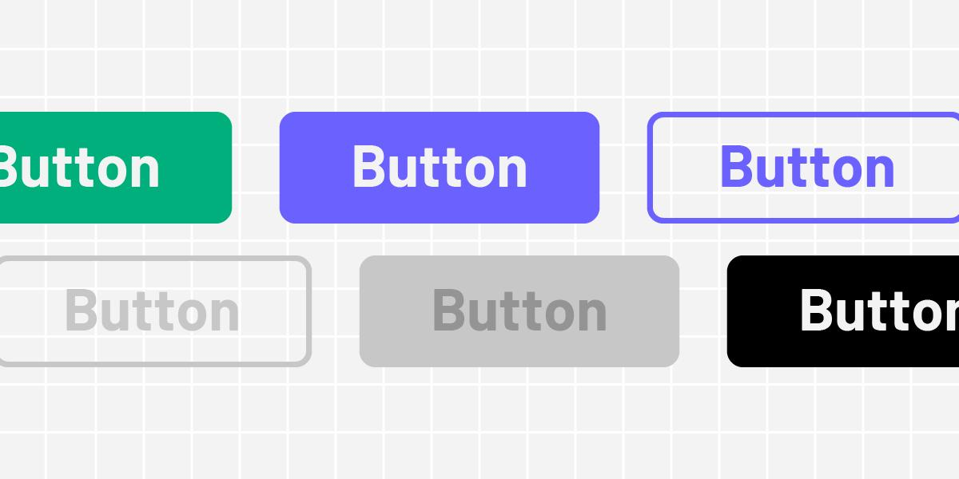
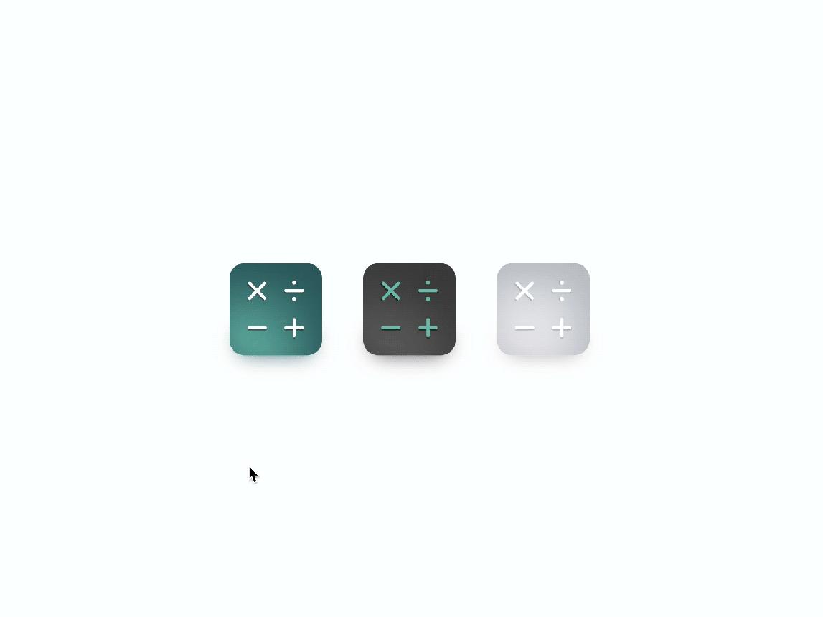

8. Apply Colors and Typography

Suggested Colors

Dark Theme
- Background: #1E1E1E
- Buttons: #2D2D2D
- Accent: Orange

Light Theme
- White background
- Gray buttons
- Blue/orange operators

Typography
Use:
- Inter
- Roboto
- SF Pro

9. Add Constraints
Constraints help maintain layout when resized.

Set:
- Button alignment
- Responsive resizing
- Anchoring

10. Prototype the Calculator
Use Prototype mode.

Example Interactions
- Button hover
- Button press animation
- Screen transitions

Steps
- Open:
  - Prototype
- Connect elements
- Use:
  - Smart Animate
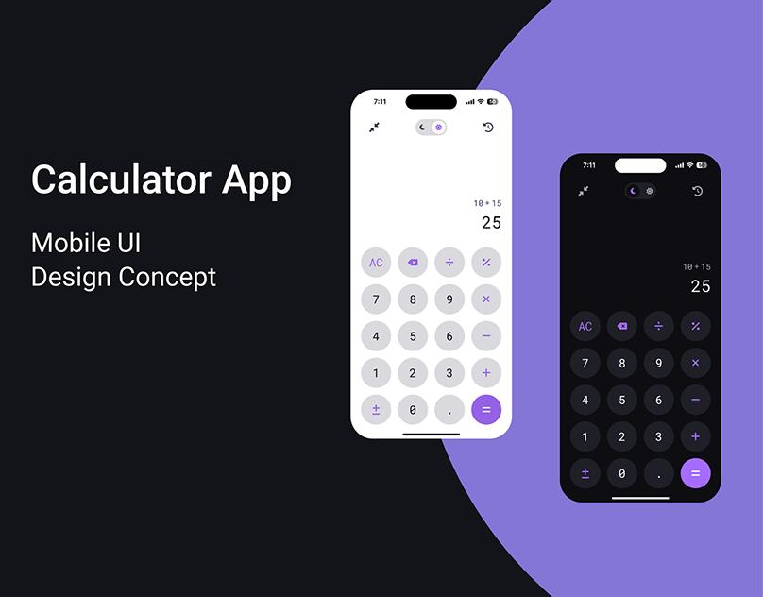
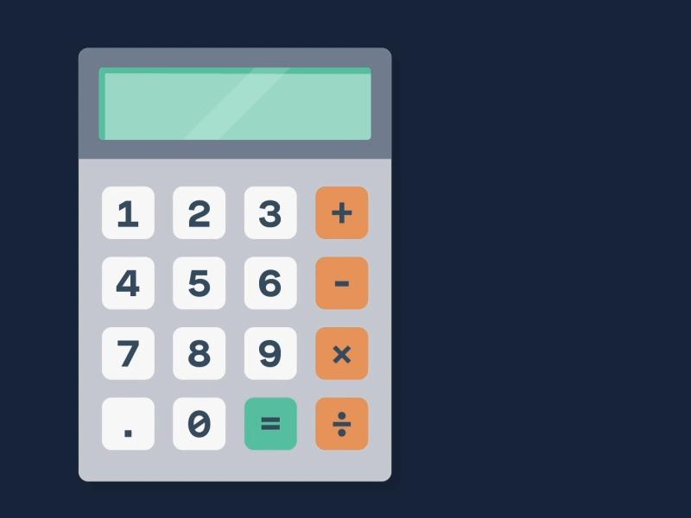
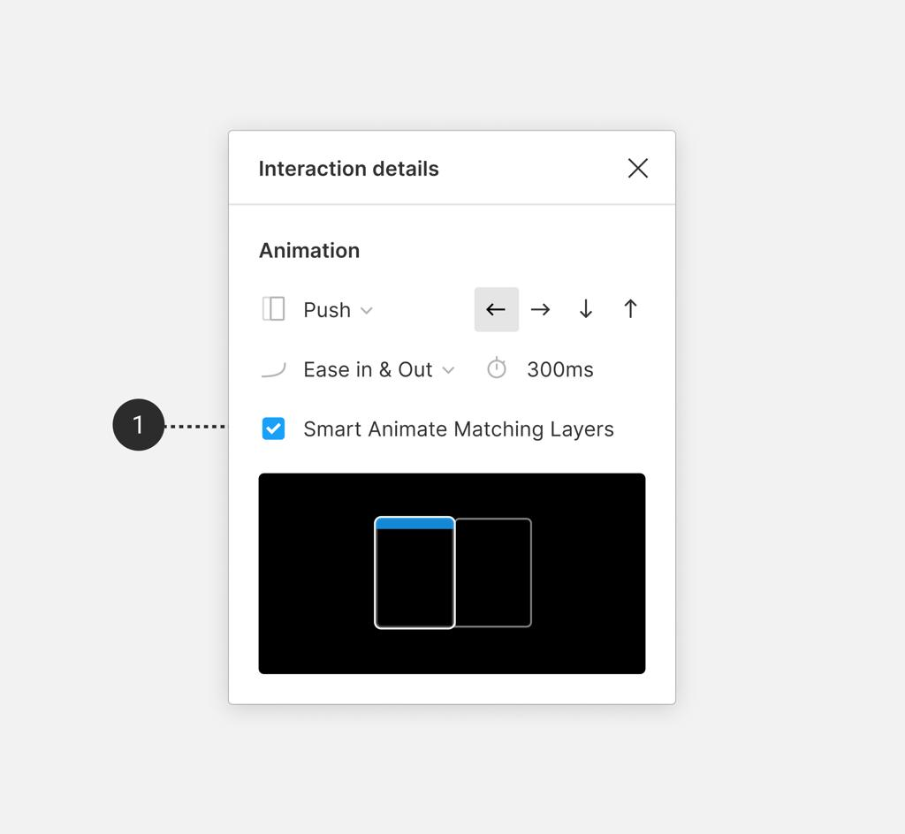

11. Organize Layers
Good layer names:
- Btn_Number
- Btn_Operator
- Display
- Main_Frame
Use:
- Groups
- Frames
- Sections

12. Export Your Design

Export Formats
- PNG
- JPG
- SVG
- PDF

Steps
- Select frame
- Click:
  - Export

Suggested Practice Upgrades
After basic calculator, try:
- Scientific calculator
- Dark/light mode toggle
- Animated buttons
- History panel
- Voice calculator UI
- Glassmorphism style
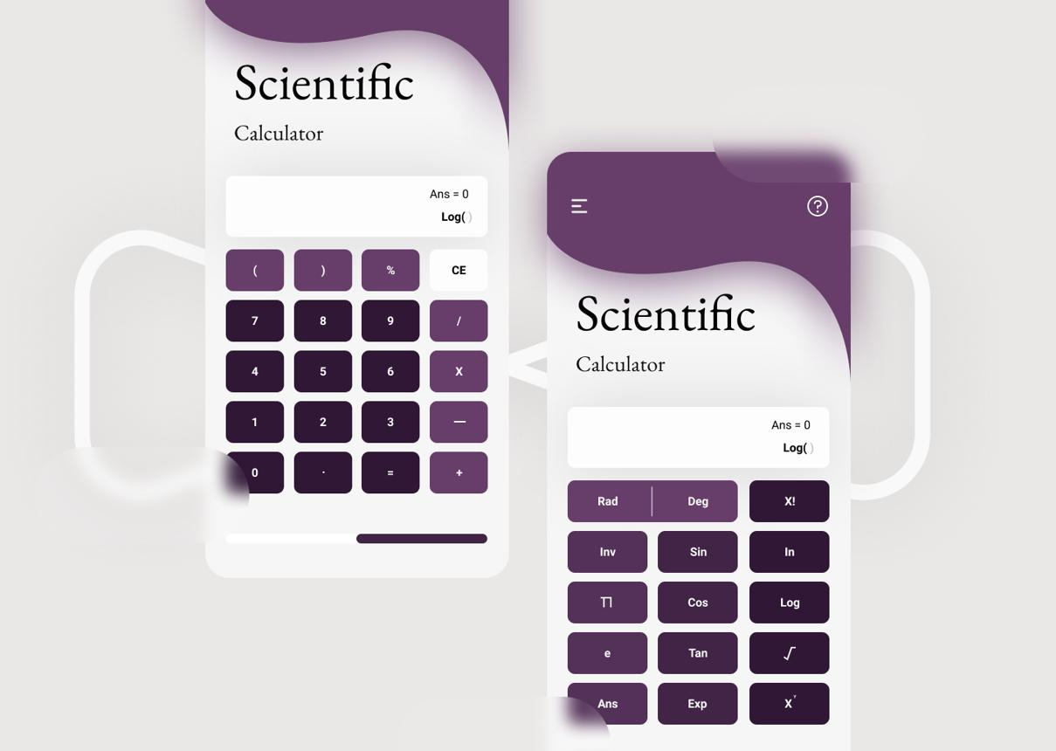
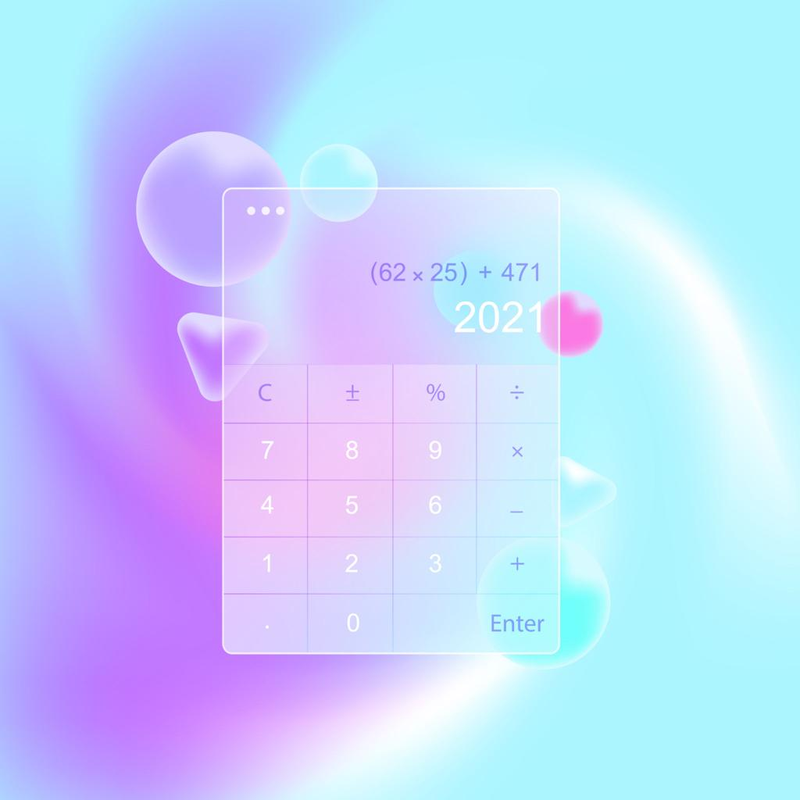
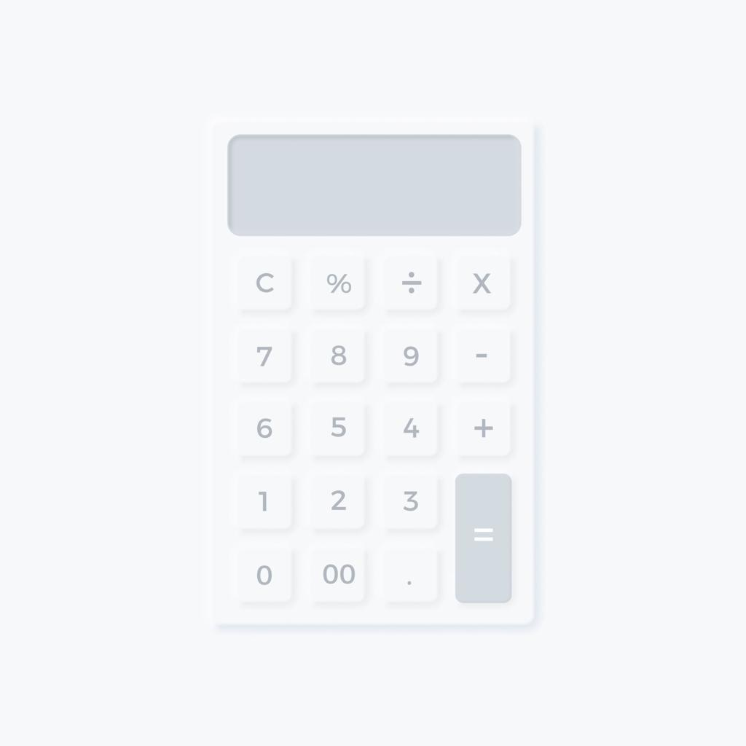

Recommended Figma Features to Learn
- Frames
- Auto Layout
- Components
- Variants
- Constraints
- Smart Animate
- Prototyping
- Design Systems
Useful learning resources:
- Figma Community Templates
- Figma Learn Prototyping
- Material Design Guidelines

